WHITE-BOX TESTING FAILED TEST CASES REPORT
Field | Details
Document Title | White-Box Testing Failed Test Cases Report
Project Name | Rankzy AI
Application Type | Web Application
Version | 1.0
Testing Type | White-Box Testing
Environment | Windows 11, Node.js, Express.js, PostgreSQL, React, Railway
Overview
This document contains all failed test cases identified during White-Box Testing of the Rankzy AI application. The failures were identified through code coverage analysis, static code analysis, duplicate code detection, and exception handling validation. Each failed test case includes the expected result, actual result, issue description, reproduction steps, supporting evidence, and developer recommendations.

1. CODE COVERAGE TESTING
TC-COV-F01: Backend Code Coverage Below Required Threshold
- TC ID: TC-COV-F01
- Section: Code Coverage Testing
- Priority: High | Severity: High
- Testing Tool: Jest + Istanbul
- Automation Framework: Jest
- Test Scenario: Verify that backend source code achieves the minimum required code coverage.
- Expected Result: Backend code coverage should meet or exceed the minimum required threshold of 80%.
- Actual Result:
  - Statements: 33.14%
  - Branches: 19.70%
  - Functions: 34.33%
  - Lines: 34.28%
- Execution Status: FAILED
- Issue Description: Backend coverage is significantly below the required threshold, leaving many execution paths untested.
- Steps to Reproduce:
  - Navigate to the Backend project.
  - Execute the coverage command.
  - Open the generated coverage report.
  - Review the coverage summary.
- Environment: Local Development
- Operating System: Windows 11
- Bug ID: BUG-COV-01
Evidence
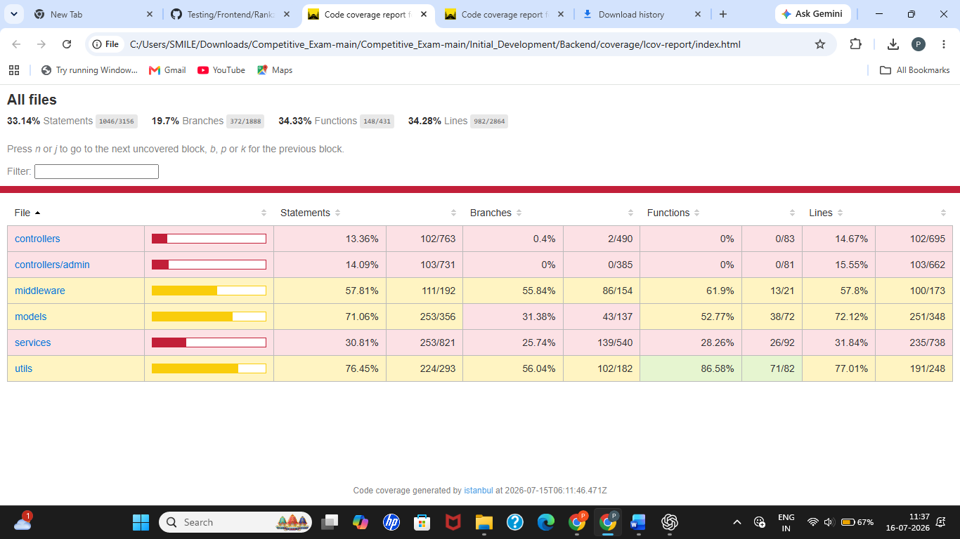
Figure COV-01: Backend coverage summary showing overall code coverage below the required threshold.
Recommendation: Increase unit and integration test coverage for controllers, middleware, services, and utility modules until the minimum coverage target is achieved.

TC-COV-F02: Frontend Code Coverage Below Required Threshold
- TC ID: TC-COV-F02
- Section: Code Coverage Testing
- Priority: High | Severity: High
- Testing Tool: Vitest + Istanbul
- Automation Framework: Vitest
- Test Scenario: Verify that frontend source code achieves the required coverage threshold.
- Expected Result: Frontend code coverage should be at least 80%.
- Actual Result:
  - Statements: 3.67%
  - Branches: 3.41%
  - Functions: 3.21%
  - Lines: 3.93%
- Execution Status: FAILED
- Issue Description: Most frontend components and execution paths are not covered by automated tests.
- Steps to Reproduce:
  - Navigate to the Frontend project.
  - Execute the coverage command.
  - Open the generated coverage report.
  - Review the coverage summary.
- Environment: Local Development
- Operating System: Windows 11
- Bug ID: BUG-COV-02
Evidence
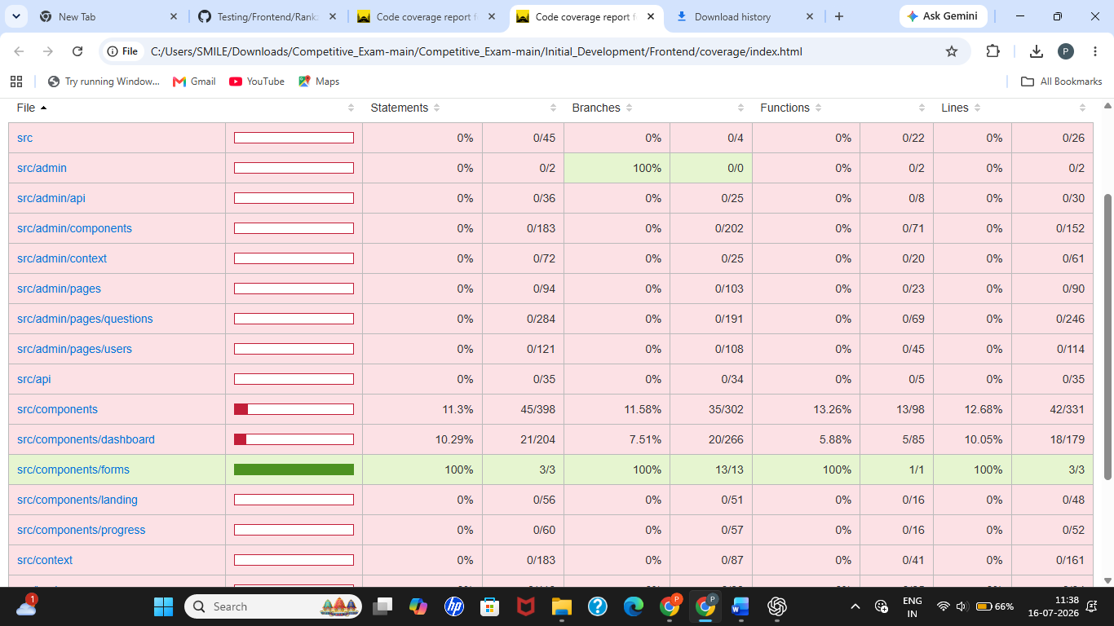
Figure COV-02: Frontend coverage summary showing overall coverage below the required threshold.
Developer Recommendation:
Increase unit testing for pages, components, hooks, and utility modules to improve overall coverage.
Failed Count: 2
Critical: 0 | High: 2 | Medium: 0 | Low: 0

2. STATIC CODE ANALYSIS
TC-SCA-F01: ESLint Configuration Error
- TC ID: TC-SCA-F01
- Section: Static Code Analysis
- Priority: Medium | Severity: Medium
- Testing Tool: ESLint
- Automation Framework: ESLint CLI
- Test Scenario: Verify that source code passes static analysis without configuration errors.
- Expected Result: ESLint should complete successfully without reporting configuration errors.
- Actual Result: ESLint failed due to the missing rule:
Definition for rule 'import/no-dynamic-require' was not found
- Execution Status: FAILED
- Issue Description: The ESLint configuration references a rule whose corresponding plugin is missing or incorrectly configured.
- Steps to Reproduce:
  - Navigate to the Backend project.
  - Execute:
npm run lint
  - Observe the ESLint output.
- Environment: Local Development
- Operating System: Windows 11
- Bug ID: BUG-SCA-01
Evidence

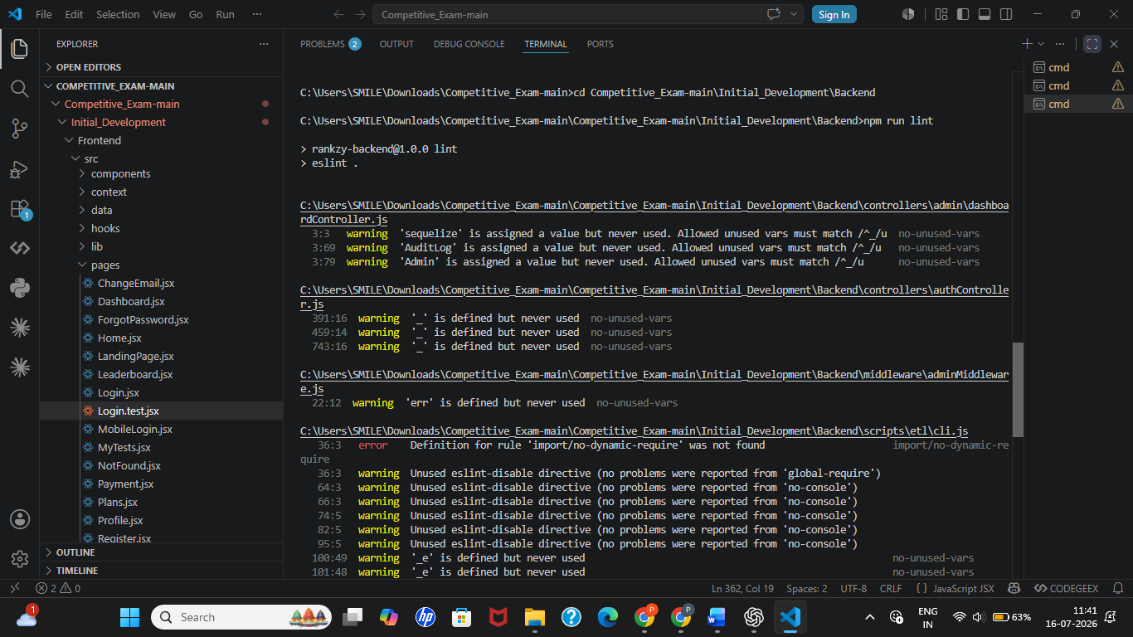

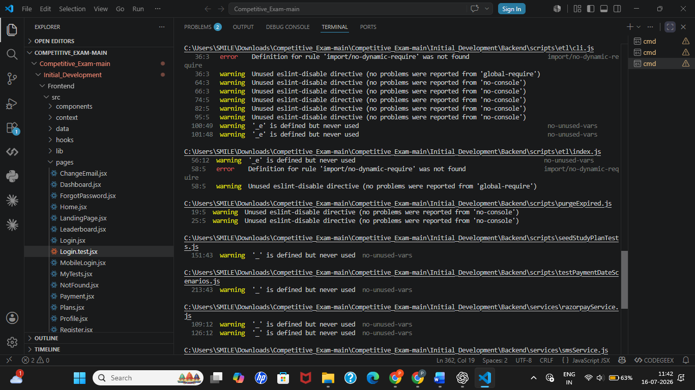
Figure SCA-01: ESLint configuration error caused by missing import/no-dynamic-require rule.
Developer Recommendation:
Install and configure eslint-plugin-import or remove the unsupported rule from the ESLint configuration.

TC-SCA-F02: ESLint Code Quality Warnings
- TC ID: TC-SCA-F02
- Section: Static Code Analysis
- Priority: Medium | Severity: Low
- Testing Tool: ESLint
- Automation Framework: ESLint CLI
- Test Scenario: Verify compliance with coding standards.
- Expected Result: Source code should not contain lint warnings.
- Actual Result: ESLint reported 35 warnings, including unused variables and unused ESLint directives.
- Execution Status: FAILED
- Issue Description: Multiple code quality warnings reduce maintainability and increase technical debt.
- Steps to Reproduce:
  - Navigate to the Backend project.
  - Execute:
npm run lint
  - Review the generated warnings.
- Environment: Local Development
- Operating System: Windows 11
- Bug ID: BUG-SCA-02
Recommendation:
Remove unused variables, eliminate unnecessary eslint-disable directives, and resolve all lint warnings.
Failed Count: 2
Critical: 0 | High: 0 | Medium: 1 | Low: 1

3. CODE DUPLICATION TESTING
TC-CD-F01: Duplicate Code Detected
- TC ID: TC-CD-F01
- Section: Code Duplication Testing
- Priority: Medium | Severity: Medium
- Testing Tool: JSCPD
- Automation Framework: JSCPD CLI
- Test Scenario: Verify that the source code does not contain excessive duplicate code.
- Expected Result: Code duplication should remain within acceptable maintainability limits.
- Actual Result:
  - Files Analyzed: 99
  - Clone Groups: 18
  - Duplicated Lines: 180 (1.87%)
  - Duplicated Tokens: 1218 (2.10%)
- Execution Status: FAILED
- Issue Description: Duplicate code was identified across multiple files, including duplicate logging implementations.
- Steps to Reproduce:
  - Navigate to the Backend project.
  - Execute:
npx jscpd .
  - Review the generated report.
- Environment: Local Development
- Operating System: Windows 11
- Bug ID: BUG-CD-01
Evidence
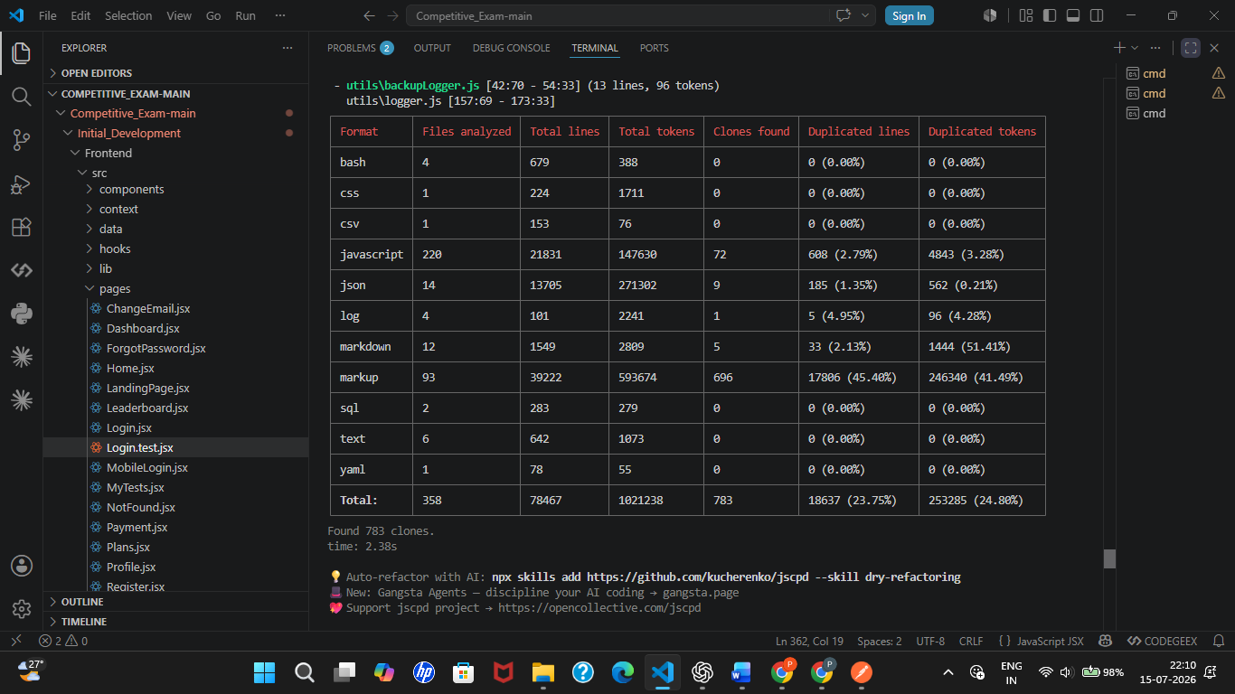
Figure CD-01: JSCPD detected 18 duplicate code blocks across the project.
Developer Recommendation:
Refactor duplicated logic into reusable helper methods to improve maintainability.
Failed Count: 1
Critical: 0 | High: 0 | Medium: 1 | Low: 0
4. EXCEPTION HANDLING / API VALIDATION
TC-EX-F01: Malformed API Input Returns Internal Server Error
- TC ID: TC-EX-F01
- Section: Exception Handling Testing
- Priority: High | Severity: High
- Testing Tool: Postman
- Automation Framework: N/A
- Test Scenario: Verify that malformed API requests are handled gracefully.
- Expected Result: Invalid requests should return HTTP 400 Bad Request or 422 Unprocessable Entity with an appropriate validation message.
- Actual Result: The API returned HTTP 500 Internal Server Error for malformed input.
- Execution Status: FAILED
- Issue Description: The application does not properly validate malformed input before processing, resulting in an unexpected server error.
- Steps to Reproduce:
  - Open Postman.
  - Send a malformed request to the API endpoint.
  - Observe the response.
- Environment: Production
- Operating System: Windows 11
- Bug ID: BUG-EX-01
Evidence
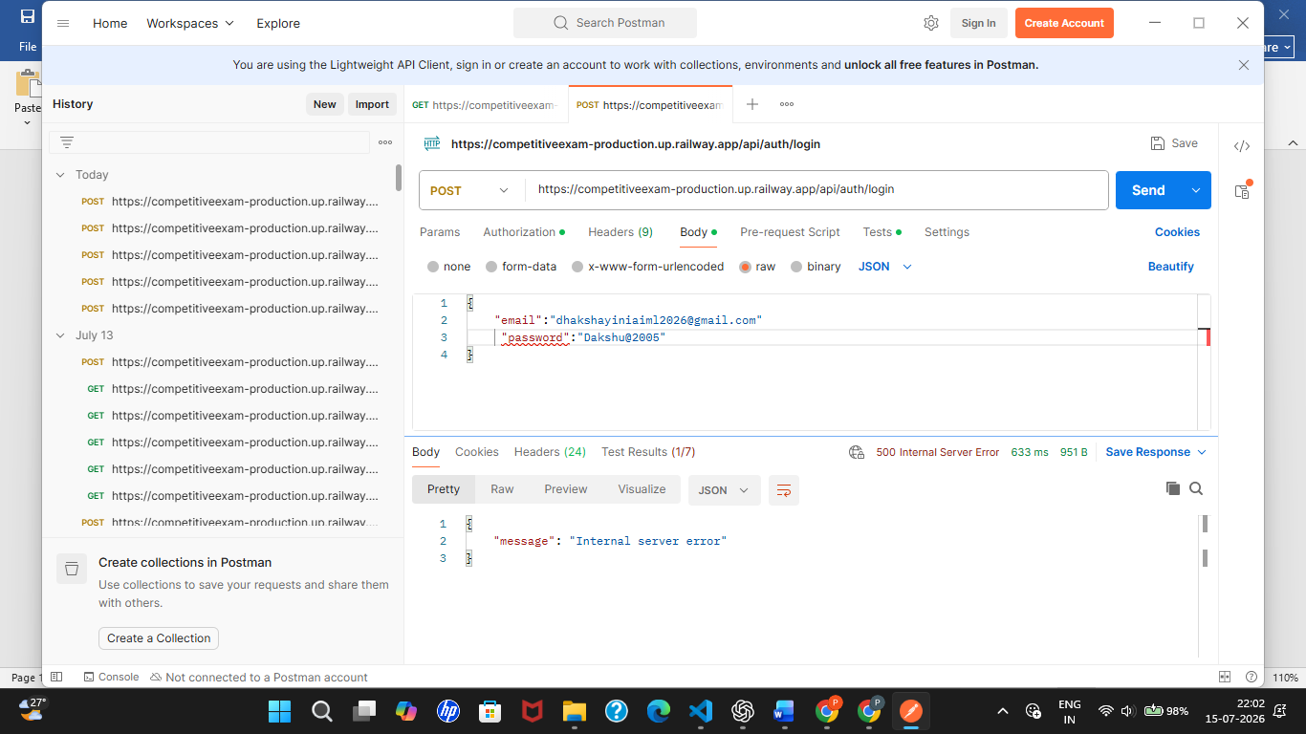
Figure EX-01: API returned HTTP 500 Internal Server Error for malformed input.
Recommendation:
Implement comprehensive input validation and centralized exception handling to ensure invalid requests return appropriate client error responses.
Failed Count: 1
Critical: 0 | High: 1 | Medium: 0 | Low: 0
Overall Failed Test Summary
Testing Section | Failed Count
Code Coverage Testing | 2
Static Code Analysis | 2
Code Duplication Testing | 1
Exception Handling Testing | 1
Total Failed Test Cases | 6

Severity | Count
Critical | 0
High | 3
Medium | 2
Low | 1
Total | 6

